
A10
Sreenidhi Institute of Science and Technology
(An Autonomous Institution)
Code No: 101MA02/111MA02
B. TECH. I – Year I – Semester Examinations, December 2015 (Supplementary)
MATHEMATICS FOR BIOTECHNOLOGY - I (BT)

Time: 3 Hours Max. Marks: 70

Note: No additional answer sheets will be provided.

Part - A
Max.Marks:20

Answer all QUESTIONS. EACH QUESTION CARRIES 2 MARKS.
1. Evaluate 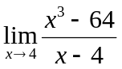.

2. Find 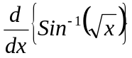.

3. If then find 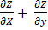.
4. Evaluate .
5. Evaluate 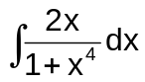.
6. Evaluate 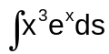.
7. Find the subnormal at any point of the parabola y²=4ax.

8. If u=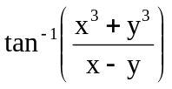, x≠y, show that x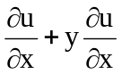=2u.
9. Solve 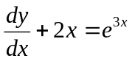
10. If f(x)=sinx, then find the area of the region under the curve from x = 0 to x = 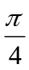.
Part – B
Max.Marks:50
ANSWER ANY FIVE QUESTIONS. EACH QUESTION CARRIES 10 MARKS.
1. a) Evaluate 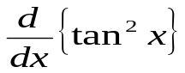.
b) Evaluate 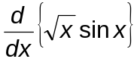.

2. a) If f(x) = 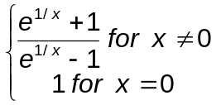Then examine the continuity of f(x) at x = 0.

b) Discuss the differentiability of f(x) = | x | at x = 0.

3. (a) Evaluate . [4M]
(b) Evaluate 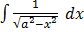 . [6M]

4. (a) Find the maximum and minimum values of
(b) If 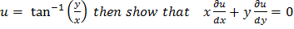 .

5. a) Evaluate 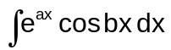.
b) Evaluate 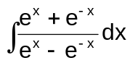.

6. a) Evaluate 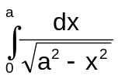.
b) Find from the definition of derivative, the derivative of f(x)=Sin 2x.

7. a) Find the maximum and minimum values of f(x)=8x⁵-20x⁴+10x³.

b) If z(x+y)= x²+y², show that 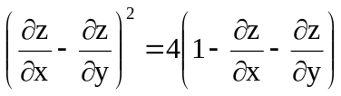.

8. a) Solve 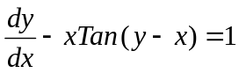
b) Solve 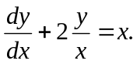

-- 00 -- 00 –

